

Apes Paper

Apes Of TON Whitepaper



1. Executive Summary
Apes of TON is a community-driven virtual ecosystem designed for crypto enthusiasts, gamers, and investors within the Telegram platform. Centered on an apes theme, Apes of TON uses a unique blend of play-to-earn, check-offers-to-earn and task-to-earn models, combined with engagement-based airdrop farming. Users earn rewards by participating in various app activities, including completing tasks, engaging with social content, and sharing offers. Through an IDO on the PadTON launchpad, Apes of TON aims to raise softcap 15,000 $TON, hard cap 40,000 $TON to speedup developments in app launch, marketing events to reach mass users through partnerships and collaborations, enabling community ownership and development.
With 95% of the total token supply allocated to community rewards (allocation in 3 parts, mentioned in tokenomics) , Apes of TON fosters sustainable earning opportunities and community value. This is more than a financial project; it is an ecosystem that empowers users to actively contribute, grow, and benefit from project success, creating a pioneering platform where reward, engagement, and social good are integrated.

2. Project Introduction
Apes of TON introduces a virtual universe on Telegram, bringing together elements of gaming, community-driven rewards, and social engagement. This Telegram mini-app enables users to engage in a wide range of activities, including:
- Play-to-Earn: Users earn tokens by participating in games within the app, with rewards scaled to time and skill-based engagement.
- Task-to-Earn: Users complete daily tasks that range from simple check-ins to engaging with app-based offers.
- Airdrop Farming: Apes of TON integrates airdrop farming through engagement on X (formerly Twitter), with users earning $APES tokens by participating in specific social media challenges, content sharing, and hashtag usage (#ApesOfTON).
- Referral and Social Media Engagement: Users can earn multipliers on their rewards by bringing in new participants and engaging consistently on X.
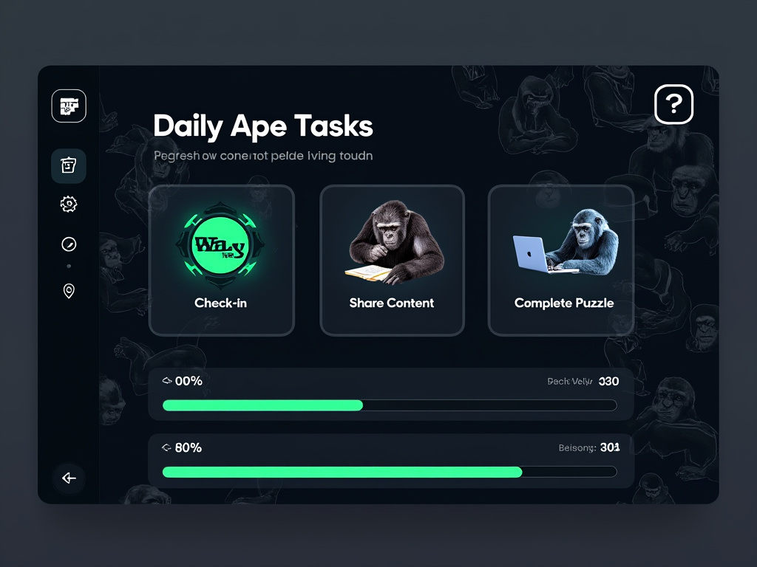
This project is more than a gaming experience; it’s a platform that allows the community to co-create and co-own a sustainable economy. Built on transparency, community ownership, and meaningful social impact, Apes of TON is positioned to revolutionize engagement and earning on Telegram.

3. Vision and Mission
Vision: To create a decentralized, community-driven platform on Telegram that combines gaming, rewards, and social good. Apes of TON aims to become a thriving virtual ecosystem where users are rewarded for engaging and contributing, thus building a strong, value-based community around shared interests and sustainable growth.
Mission: Apes of TON is committed to building a transparent, community-first project that empowers users through a fair token economy, enabling them to earn from daily engagements. By supporting causes like animal welfare, the project aligns with social impact goals, ensuring that every interaction on the platform contributes to a broader positive change.



4. Tokenomics
Apes of TON has allocated 95% of its tokens for community rewards, broken down as follows:
- 81% Community Airdrop Farming Rewards: This is the primary allocation, incentivizing users who engage in the airdrop farming mechanism.
- 7% Airdrop for IDO Participants: Tokens reserved for IDO participants will be distributed with additional benefits, allowing these early supporters to receive airdrops based on their initial contributions.
- 7% Airdrop for Influencer & KOL Partnerships: Reserved for community-building efforts, this allocation funds collaborations with influencers, KOLs, and communities in support of animal welfare.
-5% Team Allocation: Locked until trading is enabled, ensuring long-term dedication and alignment with project goals.
Allocation | Percentage
Community Airdrop Farming Rewards (Locked) | 81%
IDO Participants Airdrop Allocation | 7%
Influencer & KOL Partnership Airdrop Allocation | 7%
Team Allocation (Locked) | 5%

$APES Token Contract Address:
https://tonviewer.com/EQCUULSxjK7XvV1rWeCrdhW5f_cyt9Ri2Yjezdme904ZMvfD?section=holders

Tokenomics Infographic
Below is a graphical representation of the token distribution across various project allocations.
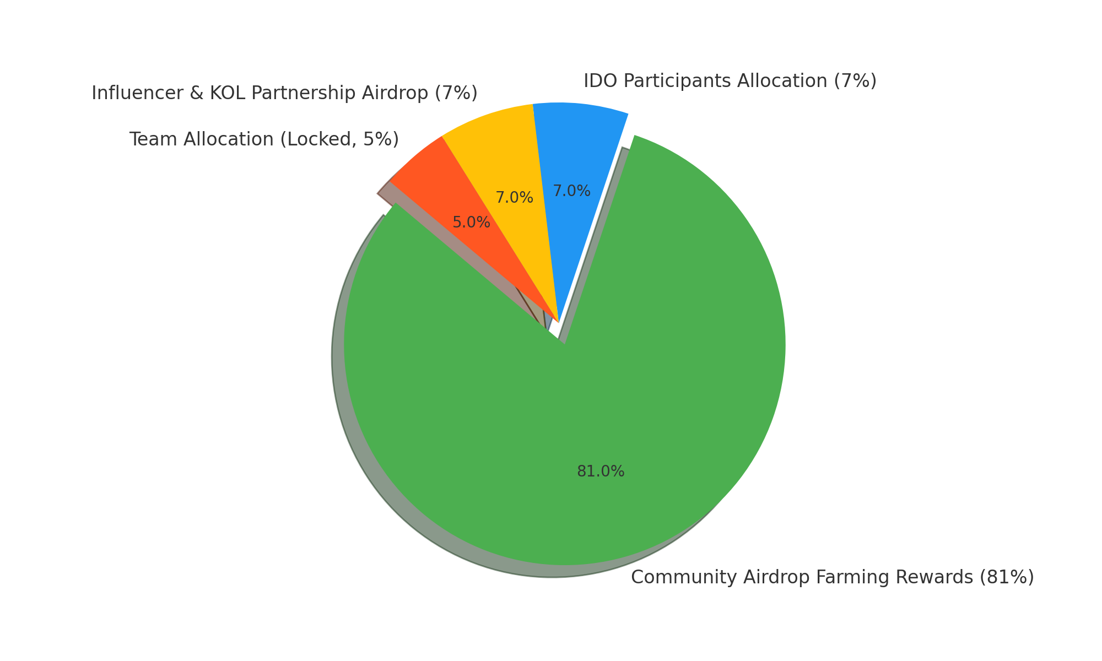

5. Airdrop Rewards Mechanism
The Apes of TON platform provides airdrop rewards to all users who engage with the app without requiring IDO participation. This mechanism incentivizes broader participation and engagement from the community. Users can earn airdrops through:
- Daily Check-ins: Simply logging into the app daily grants users a set amount of airdrop tokens.
- Social Media Engagement: Engaging with Apes of TON on X (formerly Twitter) by liking, sharing, and using the project hashtags can increase a user’s airdrop rewards.
- Referral Program: Users can invite friends to join the app and earn double rewards for each successful referral, growing both their own rewards and the community.
- Tasks and Offers: Completing specific tasks or engaging with offers available within the app will yield extra tokens.



6. IDO Participant Benefits
IDO participants in Apes of TON gain access to a range of exclusive benefits designed to enhance their earning potential and engagement experience:
- 5x Boosted Airdrop Farming Speed: IDO participants earn tokens at five times the regular farming speed, maximizing their earnings.
- Early Access to New Features: Be among the first to experience new app features and updates, giving IDO participants a competitive edge.
- Exclusive Profile Badge: Display the 'Early Ape' badge in profiles, symbolizing early support and commitment.
- Priority Support and Private Community Channel: IDO participants receive dedicated support and access to a private channel for exclusive insights.
- Voting Rights on Project Development: Influence key decisions by voting on future project developments, features, and social initiatives.
- Passive Income Opportunities: IDO participants can access staking pools, referral bonuses, and shared revenues from sponsored tasks.
- Discounts on In-app Upgrades: Receive discounts of up to 50% on in-app purchases and upgrades available exclusively to IDO participants.

7. Community Building, Collaboration, and Partnerships
Apes of TON emphasizes community building and social impact by collaborating with influencers, Key Opinion Leaders (KOLs), and animal welfare organizations. This section outlines our partnerships:
- Crypto Influencers and KOLs: Collaborations with industry experts enhance credibility and expand our outreach.
- Animal Welfare Organizations: A portion of the project's resources is dedicated to animal welfare, allowing the community to support meaningful causes.
- Micro-Influencers and Community Networks: By working with niche influencers, Apes of TON engages diverse audiences, fostering authentic and grassroots growth.

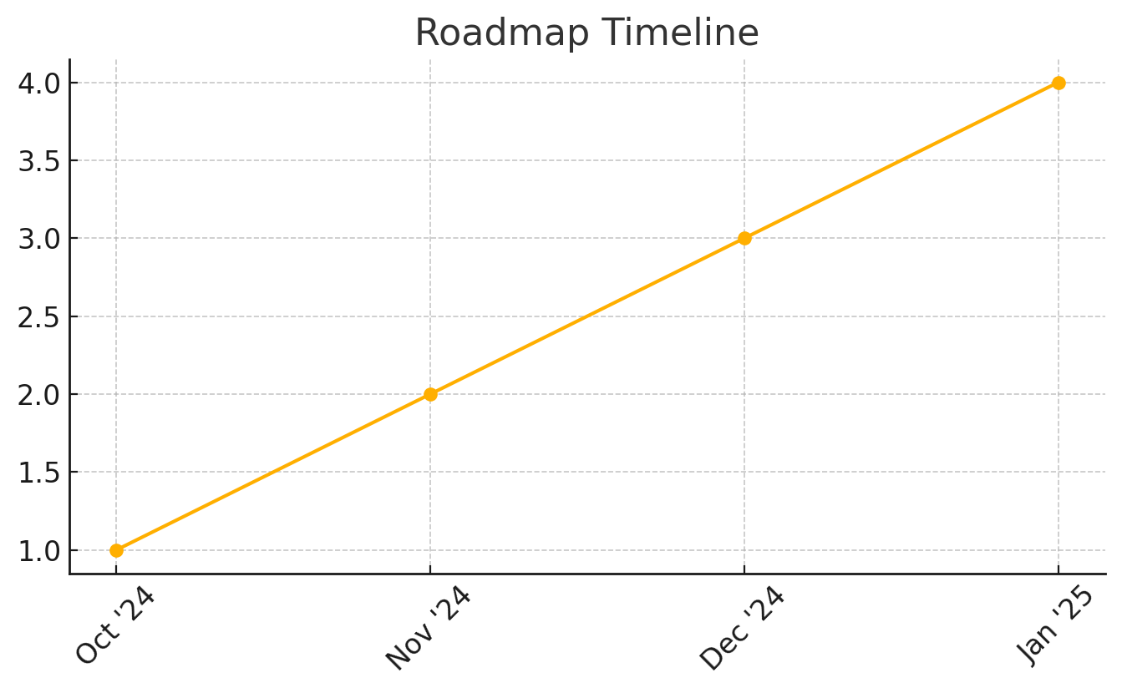

8. Roadmap Overview
Apes of TON has a clear roadmap to guide the project's growth and development:
1. October 2024 - worked on app concept, design, and execution strategies and pre-launch community activities.
2. November 2024 - Launch the IDO, onboard influencers, and initiate major marketing efforts.
3. December 2024 - Official launch of the mini-app, kicking off active airdrop farming, collaborations with KOLs, Influencers for mass user acquisition.
4. January 2025 - Implement feature updates and integrate user feedback.
5. February 2025 - Establish partnerships for mass social impact and expand project exposure.

9. Founders
Apes of TON was founded by Anand Sharma and Tanya Sharma, who bring a wealth of experience and dedication to the project.
Anand Sharma – Founder
With over a 10+ years of experience in crypto, Web3, and blockchain, Anand is well-versed in small-cap projects, strategies and is continually learning the latest trends. His vision is to create a sustainable platform that empowers users and drives social impact.
Tanya Sharma – Co-founder
Tanya handles community growth, management, and outreach. Her commitment to fostering a positive and active community ensures that Apes of TON reflects the needs and values of its users.

10. Marketing and Growth Strategy
Apes of TON’s marketing strategy combines digital campaigns, influencer partnerships, and community-driven content. Key strategies include:
- Social Media Campaigns: Run targeted campaigns on X to raise brand awareness and drive engagement.
- Influencer Partnerships: Partner with influencers to establish credibility and expand reach.
- Referral Program: Encourage users to invite others, fueling growth through word-of-mouth.
- Community Events: Host events such as AMAs, Q&A sessions, and online gatherings.
- Content Creation: Support user-generated content to increase organic reach and community engagement.

11. Risk Factors and Mitigations
The Apes of TON project acknowledges potential risks and outlines mitigation strategies to address them:
- Market Volatility: The token economy is designed with long-term locked team allocations to reduce immediate impacts from market fluctuations.
- Community Engagement: Maintaining transparency and open communication channels builds trust and encourages long-term engagement.

12. Conclusion
Apes of TON represents a novel, socially conscious ecosystem, combining blockchain rewards with community-driven social impact. By participating in Apes of TON, users not only benefit from earning opportunities but also contribute to a broader vision of positive impact. Join us on this pioneering journey and be a part of a community-first platform built on transparency, reward, and meaningful engagement.

